Lecture 7 Dielectric Optical Wave Guide
Dielectric Optical Waveguides
We have seen that, when an optical wave is incident from a high-index dielectric medium on an interface with a lower-index medium at an angle θ_{i} >θ_{C}, total internal reflection occurs. If a high-index medium is “sandwiched” between lower-index layers, then TIR can trap a wave:
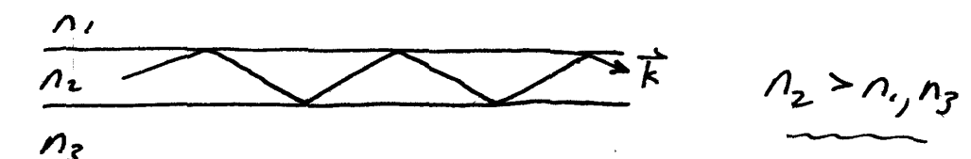
In principle, since the reflectivity is one, the light could propagate forever. In fact, only residual absorption from defects in the glass and scattering from inhomogeneities limit the propagation distance. (We will consider those loss mechanisms in detail later.) Modern optical fibers allow nearly lossless propagation over many kilometers, resulting in their ubiquitous use in optical communications.

We will begin by considering a qualitative (or semi-quantitative) description of the waveguide propagation in terms of the propagation vector .We will then actually solve the boundary-value problem to see what the “modes of propagation” are in the waveguide.

Wave vector model of slab waveguide
In general we may have n_{1≠}n₃, but we can consider the simpler case of n₁₌n₃, i.e. a symmetric waveguide, and still illustrate the salient features.
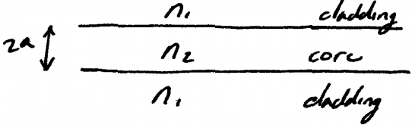

(Examples include glass waveguides, using 2 different glasses with n₁₎n₃, or semiconductor lasers such as GaAs/AlGaAs structures, where
Crucial fact: not any -vector can propagate!
Consider a -vector with magnitude propagating in the slab with an angle:
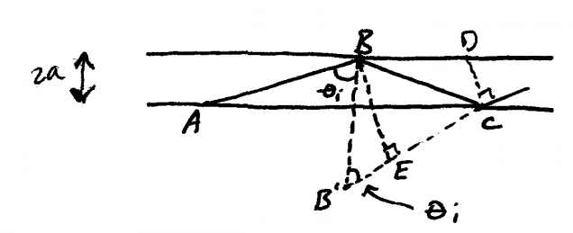
Remember that the wave fronts in the plane wave are perpendicular to .This means that the line BE must be a wave front. So must CD.

If BE is a wave front, then we must have
m= integer
(i.e. the optical path difference = an integer number of wavelengths)
Geometry: (since )
And
=> phase condition is
The values of which allows this condition to be satisfied give the directions of which can propagate “modes” (note ||=n₂ω/c is same for all modes)
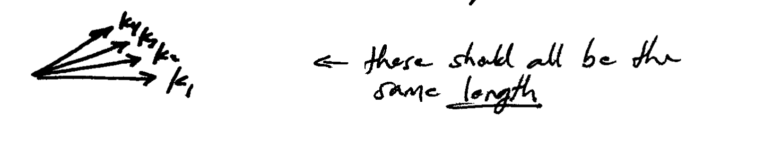
Note that is always a solution
- there is always at least one allowable mode in a symmetric waveguide.

Smaller θ_{i}=> larger m, but eventually θ_{i}<θ_{c}
And TIR no longer occurs => there are a finite number of guided modes.
Graphically, we can count the number of modes by plotting versus :
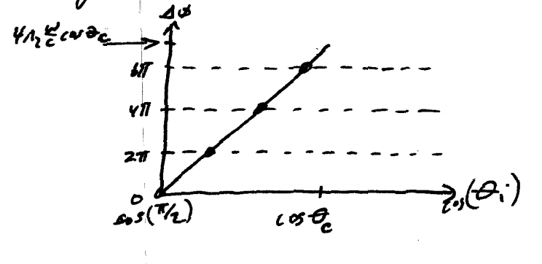
- modes=
where Int[] signifies the integer part of []
Now, this simple analysis has neglected the phase change which occurs on TIR. Of course, the phase change is a function of, and .
Thus P.A3 really should read
And the vs. plot looks like
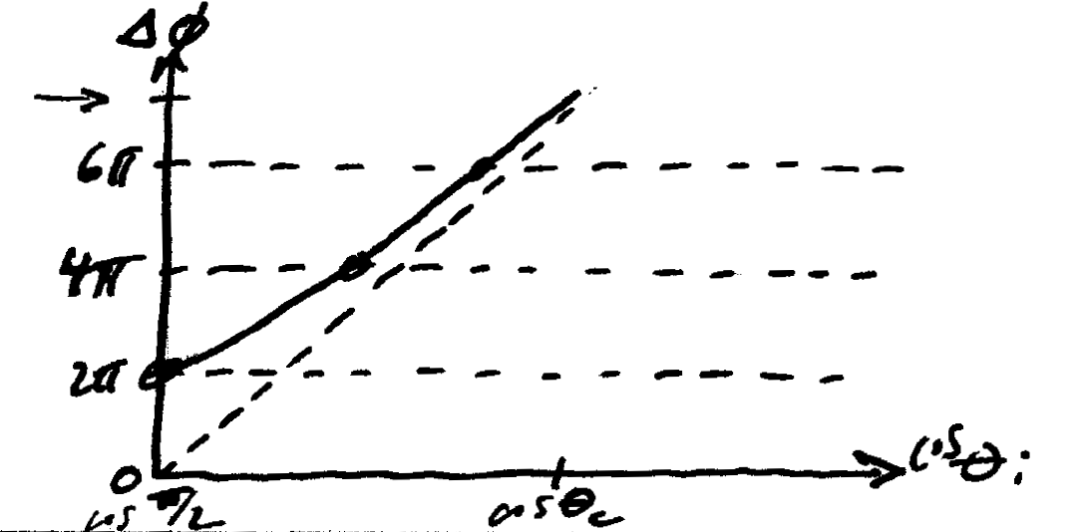

=> 0 + 2π=2π
=> m=1
=> one mode less
Of course the phase shifts , so the solutions to the phase condition are generally different for S and P polarization

Mode structure
From our simple wave vector picture we can even get a qualitative idea of what the field profile of confined modes look like. Consider the phase fronts of waves corresponding to wave vectors .
As shown
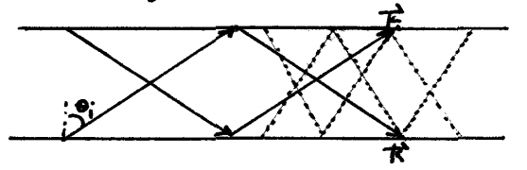

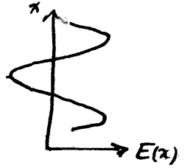
Clearly the two plane waves in this picture constructively interfere in 3 places (edges and center of waveguide)
=》expect 3 antinodes in the field profile
Obviously for propagating with larger ,there will be fewer antinodes (e.g.1 antinode when =π/2),and there will be more antinodes at smaller .
This is about all we do with the wave vector model. In order to actually determine the mode profiles, we must solve Maxwell’s wave eqn, for the slab, subject to the appropriate boundary conditions,

Electromagnetic analysis of slab waveguide
We consider a 3-layer waveguide
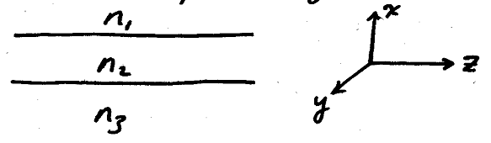
As usual, we supposeμ=1,so the index in each layer is given by j=1,2,3 and as usual
The wave eqn. (see notes P.8) is
In homogeneous media, the Maxwell eqn.
(No free change) yielded
=>
And the wave eqn. followed
Because our waveguide is a layered structure, uniform constant, but
=>
=>
If this is << , then and the usual wave eqn. results (“weak guiding approximation”).
Note that this is a consideration only for P Polarization (usually called a TM mode in waveguide problems, since the magnetic field is transverse to the x-z plane).
For TE modes, i.e. S polarization,
=> => identically.
Noting that since there is no y-variation in a slab guide, we have
Consider a harmonic wave propagating in the z-direction with frequency ω:
( in Lipson)
=> , where is the index in layer i (i=1,2,3)
Define (=vacuum wave vector)
=> j=1, 2, 3
Note that serves as a wave vector along the z direction: it is often called the “longitudinal wavevector “or the “propagation constant”.

It is critical to note that the mathematical form of the solution to depends critically on whether is greater or less than!
Let
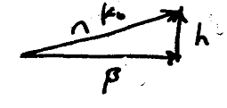
Case i : (i.e. h real )
=>
- E is of the form (or )
i.e. the solutions are oscillatory

case ii : => purely imaginary ( real )
=>
=> E is of the form
i.e. the solutions are exponentials

Now, we have .Let’s suppose
. 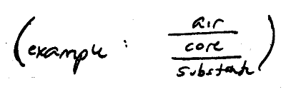
Now let’s see how the solutions change as we start with a large and gradually decrease it.
Case (a):
- Solutions must be exponential in all 3 layers.

Now we have to match the solutions in the 3 layers at the boundaries, subject to the boundary conditions imposed by Maxwell’s eqns.

Digression on boundary conditions
We saw (P.23) that the tangential components of E and H must be continuous across a dielectric boundary.

Consider S polarization (TE wave)
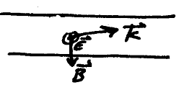
=>
Maxwell:
Now
Now the transverse component of is .Since is continuous across the boundary, clearly
must also be continuous across the boundary
To summarize, both and its derivation must be continuous across the boundaries. Similar conditions can be determined for TM waves.
Back to case (a):
in all 3 regions
Together with the boundary conditions, the mathematical solution must look like (a) in the figure below:
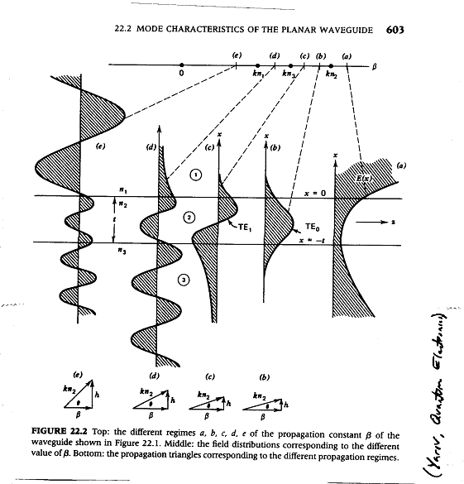
Clearly, the field increases to infinity as
This is unphysical! Such a wave would have infinite energy (worse: infinite energy density),
Thus it must not correspond to a real physical wave, even though it is a perfectly good mathematical solution to the wave eqn.
Cases (b) and (c) :
In region 2 (the core), the solution is sinusoidal
In region 1 and 3(cladding), the solutions are exponential
In order to correspond to physical waves, they must be decaying exponentials (i.e. in region 1 and in region 3, where x < 0).
Now, it is possible to satisfy continuity of both E and in this case: see figure curves (b) and (c).
These waves are confined to the core region, and thus are the confined waveguide modes, sometimes also called “guided modes”

Case (d):
Now the solution is evanescent in region 1, but oscillatory in regions 2 and 3.This is often called a “substrate mode”, since it is a mode which radiates into the substrate as it propagates.

Case (e):
Solution oscillatory everywhere => “radiation modes”

It is easy to see what is happening between cases (d) and (e), i.e. when .The magnitude of k in region 2 is => we have 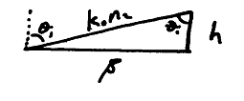
Clearly,
Recall, the condition for total internal reflection is just. Thus the transition between unconfined and guided waves is exactly the same as the transition between partial and total internal reflection.
Cases (b) and (c) thus correspond to TIR at both upper and lower interfaces, thus leading to guided waves. In case (d), the reflection at the lower interface is partial, not total, so light initially in the core is gradually radiated into the substrate cladding layer, hence the term substrate mode.

In general, the modes of the field are forced by applying the boundary conditions to the solutions of the wave eqn, in the 3 regions. We shall now do this for the case of TE modes in a symmetric waveguide.

