Lecture 27
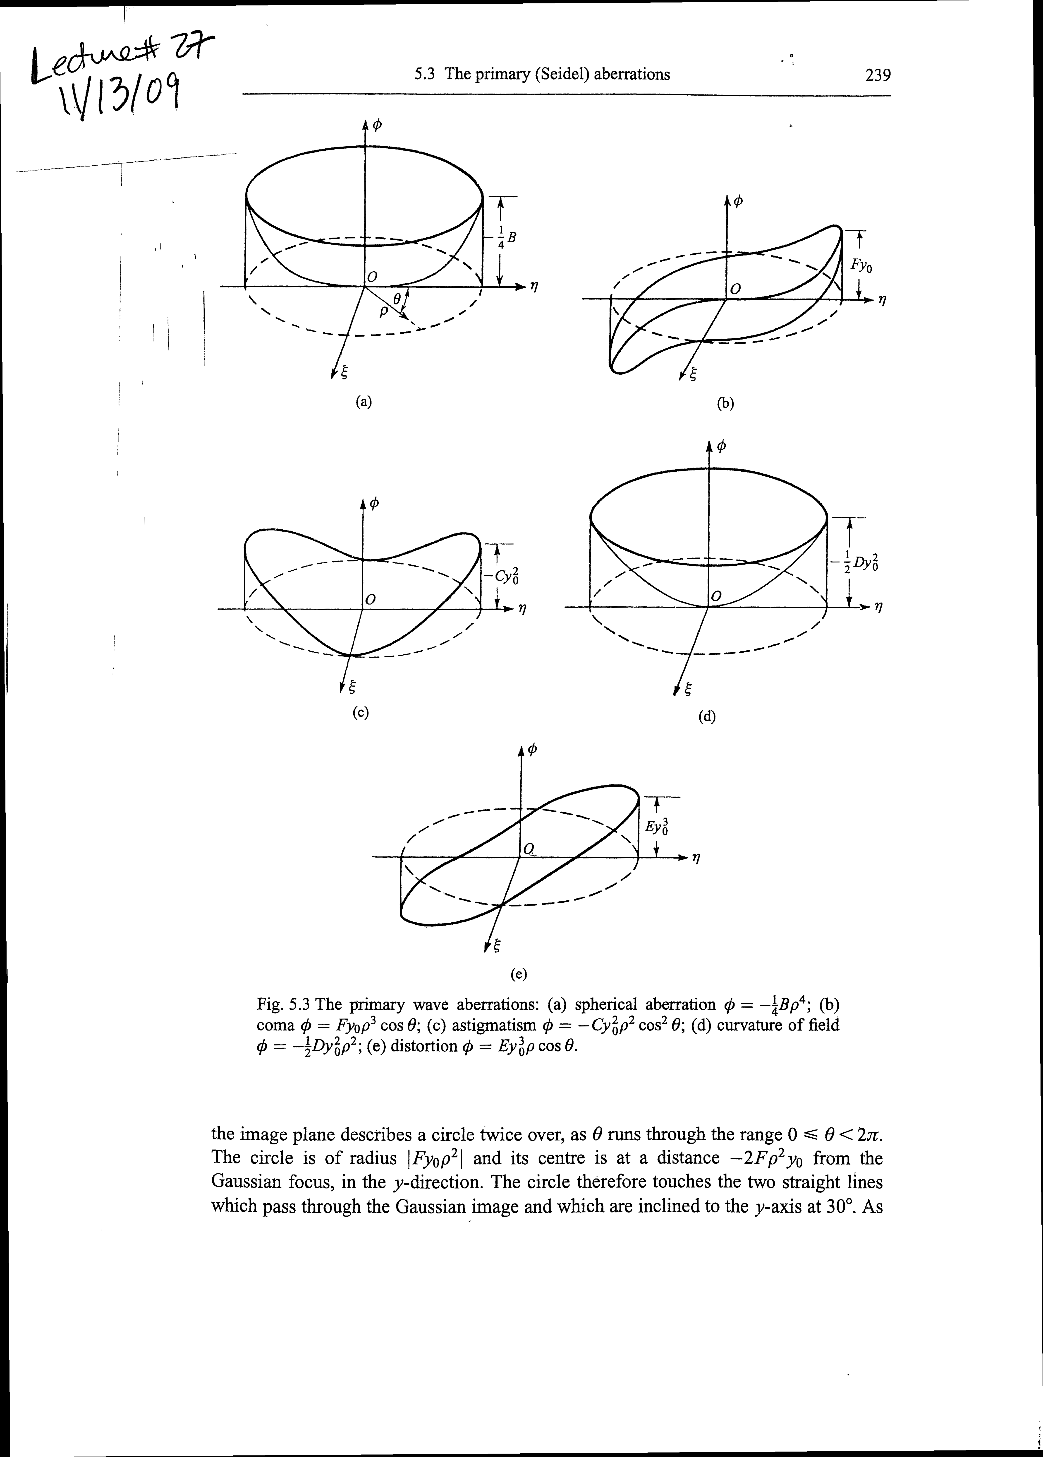

Ray (Seidel) Coefficients
- The ray durations and (from their paraxial position can be found using the fact that rays are normal to wavefronts.
One finds
(= angle of chief ray which defines the paraxial image position)
We will not show this, but it turns out that in general one can write the wavefront aberration as
We will now consider the qualitative behavior of the ray deviations for the primary aberrations.
- Spherical aberration
(independent of h or )
- This is the only “on-axis “ aberration
The name “spherical “aberration is in some ways rather unfortunate, since it has nothing to do with imperfections in a spherical surface. Rather, it signifies that a perfect sphere is not a perfect imaging system. It forms point images only within the paraxial approximation (see our discussion on P.191).
Positive spherical aberration: marginal rays intersect the axis in front of the paraxial focus, as drawn:
Longitudinal spherical aberration
(Negative spherical aberration occurs when the marginal rays focus beyond the paraxial focus)

Tracing many rays allows one to find the caustics, and hence the circle of least confusion (minimum blur)
- Of course, you would want to place your image plane (film, detector, etc.) in the plane of least confusion (note that it dose not coincide with the paraxial focal plane!)

- Note also that the spherical aberration can be reduced by “stopping the lens down,” i.e. by reducing the aperture stop. This blocks the offending marginal rays (i.e. improves the paraxial approximation). Of course, this comes at the possibly heavy price of image brightness (recall the brightness is proportional to!).
- The transverse spherical aberration is obtained by looking at the positions of the rays in the image plane (i.e.,). This is often characterized by a ray intercept plot, sharing the ray intercept in the image plane vs the height at the exit pupil.

Example

cubic behavior is the characteristic of spherical aberration

Note that the ray intercept plot is for specific conjugates. In general the plane of least confusion relative to the paraxial focal plane will change for different conjugates.

Spherical aberration can be minimized (although not eliminated) for a single-element lens by choosing the radii of curvature and appropriately .Recall that the focal length depends only on the difference (), so we have that degree of freedom to play with. Of course, the actual optical values (i.e. the ratio) change for different conjugates.

Example: most achromatic doublets are also optimized to minimize spherical aberrations for infinite conjugates (i.e. object at).
Thus of you want to image one point into another, you will do better to use two lenses:
Example: be careful in using microscope objectives! Most correct the spherical aberrations for an image distance =160 mm (the “tube length“), and are designed to work with or without a cover slip on the sample. Objectives corrected for infinity are available.
e.g. but using the same objective to collimate wouldn’t work :
Practical laboratory trick: make sure you orient a plane-convex lens so that both surfaces contribute to the refraction.
An intuitive reason why: consider a lens to be a curved prism! An exaggerated picture:
Recall from the last homework that the minimum deviation condition for over “prism” is that the entrance and exit angles be equal! This “explains “why the spherical aberration is minimum when both surfaces contribute roughly equally to the refraction of marginal rays.
- Coma
This is an aberration that arises for off-axis object points.
Physical origin: the principal planes of a lens are not actually planes (they are planes only for paraxial rays). In general, they are principal surfaces which have some curvature.
Because the principal surfaces are curved, the effective focal length and therefore the transverse magnification vary as a function of ray height

Ideal case: paraxial and marginal rays give same magnification

Position coma: marginal rays show greater magnification

Negative coma: marginal rays show less magnification
The signature of coma is the “comet” shape obtained from a single off-axis point source.

See Hecht fig. 6.19:
- Principal ray ＋vicinity => point image at P
- Marginal rays from off-axis object points produce “comatic circles “
- Image

- astigmatism

also arises from off-axis parts
This aberration basically results from a focal length difference for rays due to asymmetry. There are basically two common causes:
- as the eqns. above describe, for off-axis points the lens is effectively asymmetric
- as elliptical rather than spherical lens is also asymmetric , and will have two different foci even for on-axis points (a common case is the eye !)
This is easiest to see for the specific case of
Side view:
This is called the “meridional plane”; it contains the chief ray and the optical axis.

Top view:
This is called the “sagittal plane “; it is meridional plane and also contains the optical axis.

The meridional rays are more tilted w.r.t the lens and thus have a shorter focal length (for a positive spherical lens) than the sagittal rays.
See Hecht Fig.6.23: circle of least confusion is between two foci (which are ~ line foci if the astigmatism is large).
- field curvature
- consequence of paraxial approx. we made earlier in defining object image focal planes
i.e. a thin lens really images a spherical surface into a spherical surface

only written paraxial approx.
can these be taken as planes
- negate (i.e. flatten the field) w/ combinations of positive + negative lenses
- distortion: all points in object plane are imaged to points in image plane (stigmatic imaging ), but relative distance between points is altered
-arises when is function of off-axis image distance
Case 1 : increases

= “ pincushion“ or positive distortion
Case 2 : decreases
“barrel“ or negative distortion
(points move radically inword towards center )

