**Lecture 2**

The four boxed equations are known as Maxwell’s equations, and they hold at every point in space in an inertial reference frame.

**Free-space wave equation**

We consider first propagation in a homogeneous, isotropic, nonconducting (σ=0), source-free(ρ=0,J=0), dielectric medium.  and  are constants at all points and in all directions in space).

We have:

 

 

Since a time-varying B-field gives rise to an E-field, and vice versa, it may be possible to derive a single differential equation for. We do this by faking:



Now, 

But, , so we have:



This is the Maxwell wave equation for the electric field. If one want to eliminate E in Maxwell’s equation, one must find the same wave equation for H:



One can solve either wave equation for E and H, and then use Maxwell’s equations to determine the other. It turns out that although virtually all optics publications start with the wave equation for E, there are situations (e.g. photonics crystal mode calculations) when it is preferable to solve for H first.

Of course, you might ask, what does  even mean? The Laplace operator  operates on scalar wave equations, one for each vector component:

 j=x,y,z

Wave equations have the general form



Where f=scalar wave amplitude

v=speed (more precisely, the phase velocity of the wave)

Thus the speed of an electromagnetic wave is:



In vacuum ==1,so the speed of light is:



For most optical materials, =1,so:



Where is the familiar index of refraction.

**Plane Wave Solutions:**

The simplest solution to Maxwell’s wave equation is, of course, the simple harmonic plane wave

 =constant

Where

=propagation vector or wave vector

||=,=wavelength

It should be noted that, strictly speaking, the plane wave is an unphysical solution——it has infinite extent in both space and time. Indeed, it is well to remember that just because a particular mathematical solution exists does not mean it can exist in physical reality. So why is the plane solution so useful? Two reasons:

1. There are physical situations which are very approximated by this solution.(e.g. the central region of a well-collimated laser beam)

2. These solutions can serve us as a mathematical basis set for expanding realistic waves in. (We’ll come back to this later).

The electric field is a measurable quality, and hence must be represented as a real number. It is convenient, however, to write and then take the real part as physically relevant field.

Plugging into the wave equation, we have:



And:



So



This is called a “dispersion relation”, which relates the wave vector to the frequency.

Applying Maxwell’s equations to the plane wave, we have:



=>



Or: 

=>The field is transverse to the direction of propagation (same is true for the B field).

From the curl equation:



=>



Thus the plane wave has the following structure:

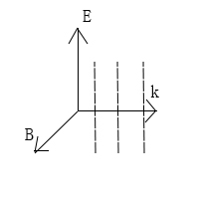here shows the wave fronts(dotted line)

(Note that,, and form a right-handed orthogonal set)

Also, E and B are in phase:

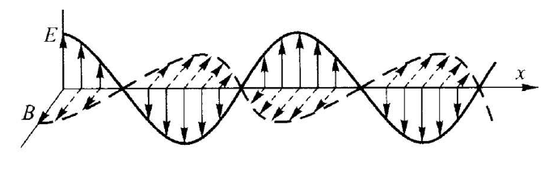

Magnitudes: 

(Thus we need only consider one wave equation-that for E or for B-and the value of the other field is fixed by the above relation)

It is often useful to consider H instead of B:



The quantity has units of Ohms(Ω),and it is called the impedance of the medium.

In free space: 

Result from circuits:

Impedance=voltage/current

Here we have the electric field (closely related to the voltage) over the magnetic field (closely related to the current).

It’s also worth recalling the definition of impedance for mechanical:

=force/velocity