**Lecture 3 Energy density and flow**

Again recalling mechanical waves, the power carried by a wave is force*velocity. By the analysis made above, we might expect the power to be related to the product .In fact, since we expect a vector quantity (since the power flow is directional), we might begin by investigating.

This is also motivated by a dimensional argument: the units of the **Poynting vector**:



Are W/m^2.

We begin by considering a charge q in an arbitrary electromagnetic field. The force on the charge is the **Lorentz force**:



If in a time interval, the charge is displaced by an amount, the work done by the field is:



Now, where is orthogonal to,so the magnetic field does no work, and:



Therefore the rate at which work is done on the charge is:



Now we can generalize to a distribution of charge in a volume .The rate at which work is done is just:



Whereis the charge density in the volume, and is the velocity of those charges.

Of course:



is just current density. Therefore in any macroscopic volume V, the total rate of mechanical work done by the field is:



This is the power transformed from the field to the charges, in the form of mechanical or thermal energy.

(This should not be a surprise. Suppose Ohm’s law applies,  then:

 (U = voltage)

As is familiar from sophomore physics.

By conservation of energy, the power transformed to the charges must be accompanied by a decrease in the energy in the electromagnetic field in the volume V.

In order to express this entirely in forms of the field variables, we must eliminate.

Ampere+Maxwell say:



So



Where I’ve been lazy and written as 

Now a useful vector identity is



Which is fine for any vector fields  and .

Then: 



In order to go any further we must make an additional assumption that the medium is linear in its electric and magnetic fields, so that the constitutive relations hold:

 and 

Then 

From electro- and magnetic-statics, we recognize this as the total energy stored in the electromagnetic field in V

And similarly 

Thus 

We can make the extension to dynamic fields as well, total E.M. energy density



Now define the **Poynting vector:**

 (for real fields)

We have



Since the integration volume is arbitrary, we may say that the integrand must hold at all points in space, and:



This is in the form of a continuity equation, so if:

=change in energy density in field

And =change in mechanical energy of particles

Then =the flow of electromagnetic energy

It is also useful to go back to above and use Gauss’s theorem 

For shorthand, we can write:



andbecomes

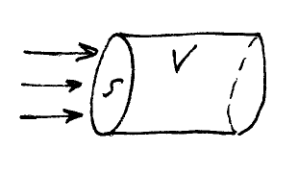Thus the total change in energy in the volume V is given by the net flow of energy through the surface *S* that bound V.

Simplest case: in vacuum: 

Of course, we are most interested in the power flow that we would measure directly. Light detectors are generally “square law detectors” which measure power and not electric field, for the simple reason that they are too slow. The fastest light detectors we have (made by picomatrix, a spin-off of UM!) have a band width of a few hundred GHz, whereas the optical field oscillates at ~1015Hz, and 1011Hz<<1015Hz!

Therefore a photo detector measures a time-average of the incident power.

**Ex.** Plane wave

Note: We have defined the Poynting vector for real fields. If you want to use complex fields, a slightly different definition is called for.



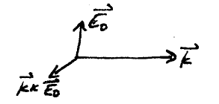From Maxwell/Faraday: 

 ()



Note that for our simple plane wave, the energy propagates in the same direction as the phase advance or wavefront (i.e.). This is generally true in isotropic media, but turns out not to be true in anisotropic media (such as birefringent crystals)

Now we want the time average:



In general, T is very long compared to an optical wave, but we can fake  and

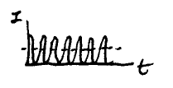 

So we have:

 (W/m2)

This is commonly known in the laser community as the intensity of the beam. It is worth noting that this is not, unfortunately, a universal terminology. In the radiometry community *which is more careful with its definitions),  is actually known as the irradiance. In accordance with common usage, we will use these terms interchangeably.

**Momentum**

Since an e.m. wave carries energy, it should also carry momentum, and thus exert a pressure on anything which reflects or absorbs light. Consider a wave incident from a vaccum onto a region containing charges+ currents:

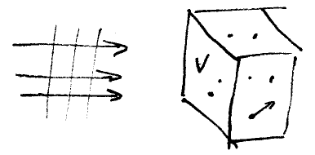Lorentz force on microscopic charges:



So we have force density.

Maxwell’s equation may be used to eliminateand:

 



Now consider 

Then 

Where we have added  to the right hand side to symmetrize the equation.

The net force exerted on the matter in the volume V is obtained by integrating over the volume, so:



Now the space force is the time derivative of the momentum, so we may write:



Where:



Is the linear momentum associated with the field? Often it is said thatis the “momentum density” associated with the electromagnetic wave. What about the r.h.s? We will not carry out the calculation, but it can be shown that it can be written as



Where:



Is called the”Maxwell stress tensor” (2nd rank tensor). Thus * is an expression of a momentum conservation law for electromagnetic fields. The r.h.s is basically the force on the surfaces bonding the volume V.

We will not further concern ourselves to the most general case, but consider only simple cases, such as complete absorption of the wave by the material in volume V. The pressure exerted by the radiation on the volume is:



In the Δt, the light propagates a distance cΔt, so the relevant volume is 



Of course, a time average must be taken:

