Lecture 8
Symmetric slab waveguide: TE modes ()
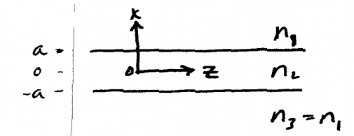
Since the waveguide is symmetric (i.e. there’s no way of knowing a priori, what is “up” or “down”), the solutions to the wave eqn. must be symmetric or antisymmetric.
Region 1 :
Region 2 :
( = symmetric mode amplitude, = antisymmetric)
Region 3:
(x<0 in region 3 => decaying exponential)
Now we need to match these solutions at the boundaries
Such that E and are continuous
Note by symmetry
Let’s first consider the symmetric modes: at x = a
(Matching E)
(Matching)
Divide:
It is desirable to express this in a dimensionless form
(i.e. scale the transverse wave vector and evanescent decay constant to the waveguide dimension a : (i)
For the antisymmetric modes
(ii)
Now, and h are not independent variables! They are connected via the longitudinal wavevector:
(iii)
Note: the above is Lipson’s notation
Better: define a dimensionless V-number by
This will match better with our definition of the V-number later for optical fibers.
(The dimensionless form is also more common in the current literature.)

Thus we have two unknowns and h (which then determine),and two equations which must be solved simultaneous to determine them [(i) and (iii) for the symmetric modes,(ii) and (iii) for the antisymmetric modes].
Symmetric:
This equation has no analytic solution, so a numerical or graphical method must be used to find h.

e.g. plot versus for equations (i) and (iii) .Eqn.(iii) clearly yields a circle,(i)~:

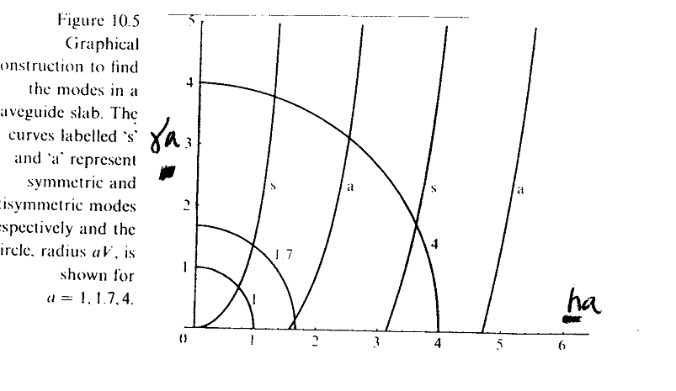
There are several points to note:
- The intersections of the two curves determine h and, and thus. The resulting discrete values of determine the “propagation modes” of the waveguide. The values of so determined are often called the “eigenvalues” of the modes.
- There is always at least one mode (lowest-order symmetric mode) which can propagate in a symmetric waveguide. This is not necessarily true in an asymmetric guide ().
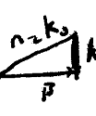
- As h increases, higher-order antisymmetric and symmetric modes become allowed (they alternate). As expected from our wave vector-model discussion, higher-order modes correspond to a larger number of nodes in the field profile:
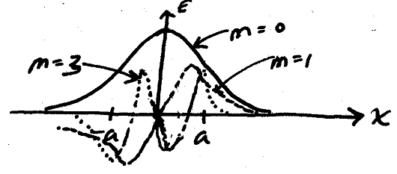
- Higher-order modes (for a given value of aV ) have a smaller than the lower-order modes
  - they are “less confined” to the core
(also have a larger value of h => more oscillations within the core –see fig. on A16)
(5)Because of (#), different modes will propagate with different velocities; this is called modal dispersion (see lipson 10.2.3)
Note that multi-mode signals will distort as they propagate => for optical communications one generally requires single-mode propagation: It is easy to show that single-mode operation is obtained if the core is sufficiently small for a given index difference and a given wavelength:
(where is the free-space wavelength).
(6)The number of modes is easily shown to be
(7)Suppose we label the modes as m=0,1,2,3,```
(even m for symmetric modes, odd for antisymmetric ).
The propagating field is
(Actually, it’s independent of y for a slab waveguide, but the form is usual for fibers and ridge or 2-D, waveguides). The “spectrum” of (i.e. the set of all allowed) is discrete for the confined modes.
The spectrum of the radiation (unconfined) modes is continuous –i.e. any value of is possible.
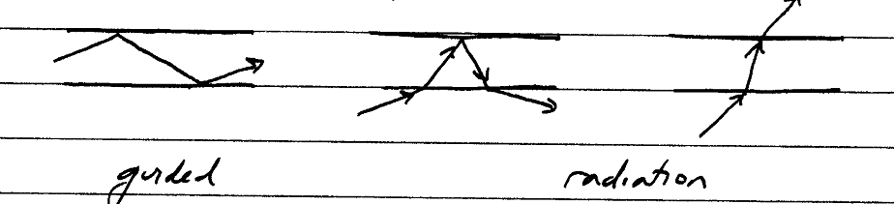

(8)Dispersion diagrams
It is often useful in many optical systems (not just waveguides) to consider a plot of the allowed propagation constants as a function of frequency, or vice versa.
For simplicity, we’ll consider just the symmetric slab waveguide here.
Recall when,no modes are possible
when ,have radiation modes
when ,have discrete confined modes
Determined by eigenvalue eqn. or graphical solution
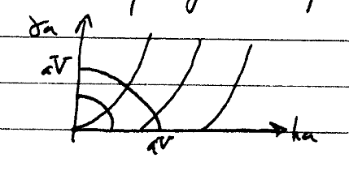
Note
  - increasing the frequency (for a fixed slab thickness a )
Increases the radius of the circle
  - get successively more discrete modes

-- using, we can see that as increases, the corresponding value of for a particular mode will also increase
-- (an accurate plot of course requires a numerical solution to get the actual value of )
Thus the modes may be plotted qualitatively as follows
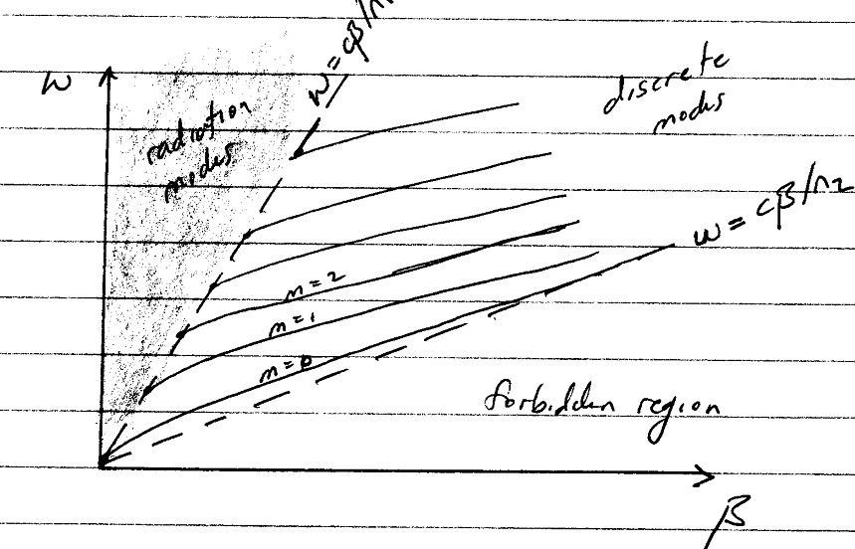
(8) The modes of the waveguide are orthogonal.
This may be shown via the following argument.

The Poynting vector, integrated over the cross-sectional area of the beam, must be constant with propagation distance z if energy conservation is to hold.
Now, suppose we represent some arbitrary field as a sum of propagating modes:
With the corresponding magnetic field
Then the energy conservation condition becomes
The just brings down a factor:
Now, when,so ,this is trivially satisfied.
When ,then we must have
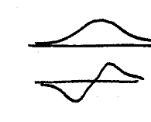
This is the orthogonality relation.
Simple case:
(proof left to reader)
(9)The modes form a complete set.
This means that any propagating field distribution in the waveguide can be written as a sum over modes.
The (expansion coefficients) are factors determining what “weight” each mode has in contributing to the total field.

Note some physical consequences:
- The modes are orthogonal, so you can’t expand one mode in terms of the others. Thus if an input beam only excites one mode (e.g. m=4),then only that () mode will propagate.
- Remember the modes propagate with different velocities. Suppose you inject a pulse which has a transverse field profile which excites 3 modes. What comes out the other end of the waveguide? Three pulse ,of course!

We have been discussing these features of modes with respect to the slab waveguide, but the basic concepts still hold for waveguides which confine the wave in two dimensions(i.e. both x and y)

e.g. rectangular waveguide
We will not treat this problem in any detail (see,e.g, Pollock’s Fundamentals of Optoelectronics), except to note the qualitative form of the modes.
In the case two mode indices are required, one corresponding essentially to the # of antinodes in the x-direction, the other for the y-direction.

