**Preface: A note on the meaning of the term “classical optics” and the scope of the subject**

All known electromagnetic propagation phenomena are completely and accurately described by Maxwell’s equations. In other words, the propagation of light is perfectly described by the classical Maxwell equations.

Where is quantum mechanics required, and classical model become futile? Only in the interaction of light with matter (i.e. emission+ detection of light, especially at low light levels). There are two levels of theoretical description:

1. Semi-classical theory:

-Light described by classical Maxwell equations.

-Matter (atoms molecules...) described by quantum mechanics (Schrodinger’s equation)

2. Fully quantum theory:

-In this case the Maxwell equations are quantized, so both light and matter are treated quantum mechanically.

-Can account for all known optical experiments.

The quantum theory of light introduces the concept of a “photon”=quantum of excitation of a mode of the electromagnetic field.

It is a word we do not need, and should not use in this course?

The relationship between theories of optics:

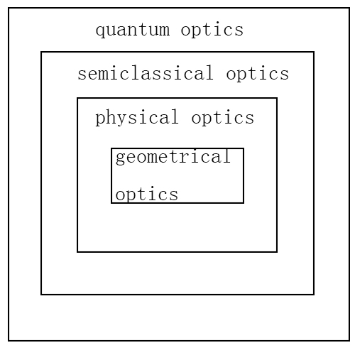

Note that the historical development basically follows this diagram---inside-out!

If time permits, we may have a bonus lecture on the relation between quantum and classical optics (“What is a photon?”) towards the end of the course.

**Lecture 1 Electromagnetic Optics and Maxwell’s Equations**

Reading: Born Wolf 1.1-1.5

Review: Hecht 3.1-3.4, Guenther ch.2

The electromagnetic theory of optics begins with Maxwell’s equations. In fact, the electromagnetic theory forms a complete theory of optical propagation phenomena, capable of describing all known observations on the propagation of light. (the only phenomena requiring any extension of the theory are the emission and detection of light, which require quantum theory for their complete description.)Here we remind ourselves of some basic properties of electric and magnetic fields, with a goal of understanding the physical nature of an electromagnetic wave.

**Electric field**

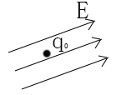The concept of a field is usually introduced by saying that a test charge  introduced into an electric field  with a force: .

Recall that there are two ways of generating an electric field:

1. **electric charge: Gauss’s Law in vacuum:**



i.e. the total electric flux through a closed surface is equal to the net charge within the enclosed volume:

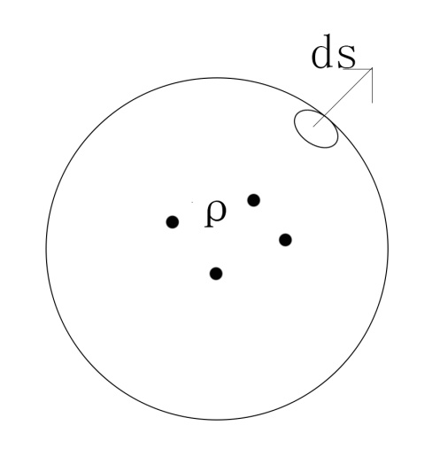

ρ=charge denisity=ρ(r)

=electric permitivity of free space=8.8X10-12 C2N-1m-2  (mks units)

Recall Gauss’s theorem for a vector field:



We can consider Gauss’s theorem for an arbitrary volume, in particular for an arbitrary small volume element dV. Then it is clear that we must have:



Where  is the (uniform) charge density in dV.

Thus at any point in the space, the divergence of the E field is determined by the charge density at that point in space.

In many (indeed most) cases in optics, one need not consider the electric field due to all the microscopic charges in a material (i.e. all the molecular and nuclei making up and construct molecules).The microscopic electric field varies wildly on the molecular spatial scale, but of course the wavelength of light is generally much larger than the scale of molecules.

(Bohr radius)

=> of interest in optics is a macroscopic field, i.e. the macroscopic field averaged in general.(see J.D. Jackson 2nded section 6.7 for a detailed discussion of the averaging procedure)

In a so-called dielectric medium, the charges (electrons) are generally bound in the constituent molecules.

=>an external electric field  will induce a dipole moment (i.e. “polarize”) in each molecule.

Again, in optics we are interested in the macroscopically averaged polarization.

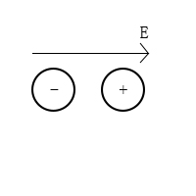

=>labeling the type of molecules in the dielectric by indexes i:



=molecules of type j/vol

=”polarization” or “polarization density”

(Dipole moment/unit volume)

In a linear medium



Where  is a dimensionless constant of proportionality (the “susceptibility”)

[digression: if the electric field is strong enough, the molecule can no longer respond in linear fashion, and the polarization may be nonlinear in the applied field:

e.g. 

We now define a new vector field, called the electric displacement:

 (in a linear medium)

Where =electric permittivity (or dielectric constant) of the medium

Note that



Different people writes:



Where

=relative dielectric constant

(Dimensionless)

Why go through this exercise now? It turns out (the calculation is left for the reader), that by defining the electric displacement, one can recast Gauss’s Law in a dielectric medium as:



where is the free charge density in the medium. In a neutral medium (e.g, glass) =0,so that one has to deal with only the simple form of Gauss’s Law .

**(2) Faraday’s Law**

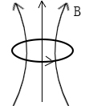

The second way of generating an electric field is with a time-varying magnetic field, as embodied in Faraday’s Law of induction:



(Recall the freshman physics experiment: loop of wire+ moving magnet).

While the equation describes the electro-motive force generated in a real loop of wire, it also holds as a relationship between the fields for an arbitrary loop in free space.

Thus we can apply Stokes’ theorem



To an arbitrarily small loop to obtain a relation between theand fields valid at all points in space:

 -----🡪Faraday’s Law

**Magnetic Field**

Gauss’s Law: 

In other words, there is no “magnetic charge” (i.e. magnetic monopoles), so the B-field can have no divergence.

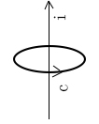Ampere’s Law says there are two ways of generating a magnetic field:

1. a current:



=magnetic permeability of medium= 

Where =permeability of vacuum=  (mks units)

And =dimensionless relative permeability

Defining  and using Stokes again, we have the vector form of Ampere’s Law:



Maxwell’s famous contribution was to note that the equation of continuity:



Is violated unless Ampere’s law also includes the displacement current, so:



1. So we see that a time varying electric field can also give rise to a magnetic field.