Lecture 11
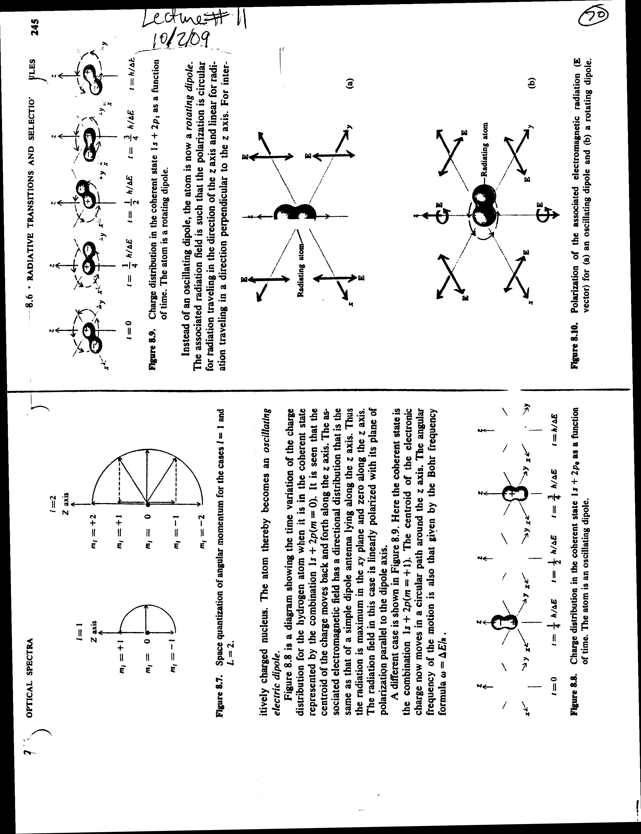

-How is the atom put into such a superposition state?
field incident on atom => it “shakes ” the electron cloud
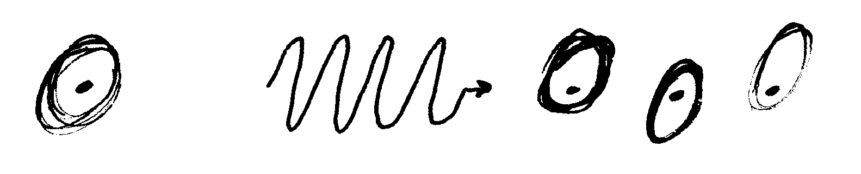
How do you describe the displaced wave function in terms of the original states?
(Superposition principle)
As usual, find coefficients by
Note that the 2 largest coefficients will be
(if , then these will be essentially the only nonzero coeffs,) => field puts atoms in superposition state .
Thus, although we cannot make antennas at optical frequencies, we can use the little antennas nature provides us with, namely oscillation atoms and molecules.

Review of electric dipole radiation
In the course of developing the CEO model and its consequences, we are going to need to recall the main features of electric dipole radiation. The proper development of the theory is best left to your electromagnetic course; here we only have time and space to outline the approach and main results.

The wave equation for the vector potential is similar in form to that of the fields:
It can be shown that the solution to this equation can be generally expressed as (see, e.g. Jackson dep.6)
The δ-function guarantees that
= retarded time
= “retarded vector potential”
If the current oscillates harmonically
Then the delta function gives
The region in which is very small (atoms, remember), i.e. ,so we consider
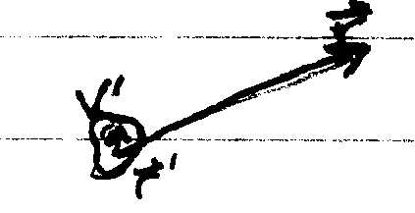
In the electric dipole approximation, we keep only the leading term:
(Keeping higher order terms gives radiation from magnetic dipoles, electric quadruples, etc., which need not concern us here.)
Remembering that bounds the currents entirely (so on the surface of ), we can put this in a more familiar form by integration by parts :
Where we have used
Define electric dipole moment by
(note similarly to quantum expression in P.69)
= >
From this we can get the fields via
And (from , )
We need only consider the special case of dipole oriented along the z-direction:
Then in the “far field” (r>>l)
The Poynting vector is thus radial:
See Figs. on following page
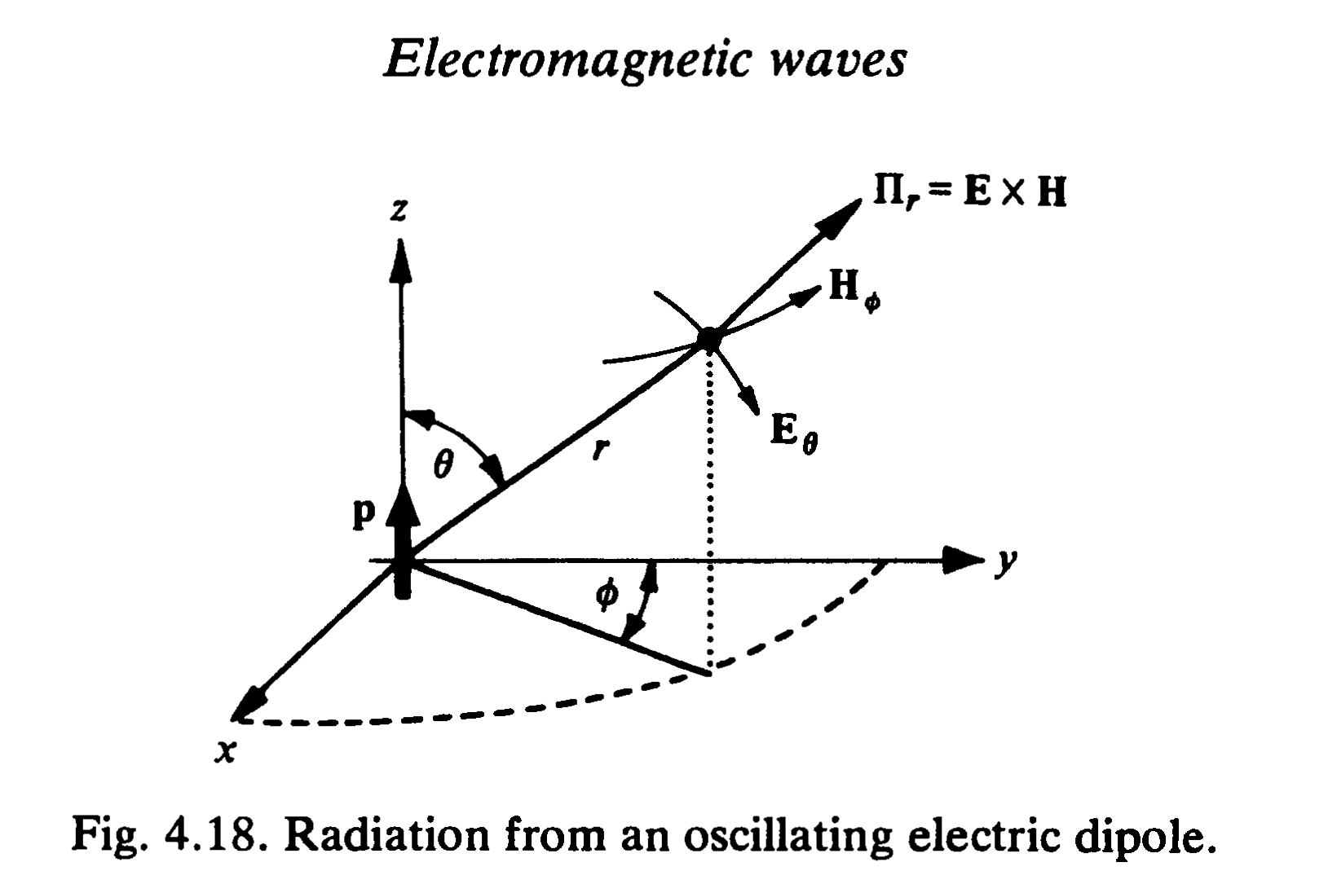
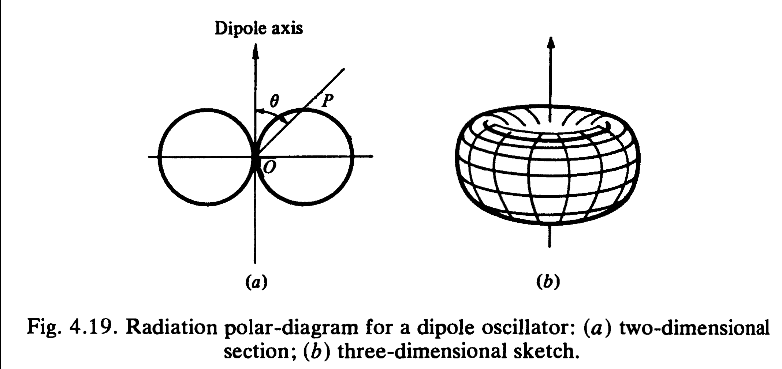

Notes
(i) Wave is of form of spherical wave, modulated by (amplitude ~ , power ~ )
(ii) Power proportional to square of dipole moment
(iii)Power proportional to fourth power of frequency

The total power radiated by the dipole averaged over an optical cycle is

Radiative decay
The most immediate consequence of the above formula is the phenomenon of radiative decay. Suppose an atomic oscillator is at form set oscillating with an amplitude , but no further power is used to drive the oscillator. The dipole will radiate power, and consequently, by conservation of energy its amplitude p must decay in time.

If we write, then the energy in the oscillating dipole is
The energy can be shown (exercise) to decay in time as
Where is the “lifetime” of the oscillator
The radiative decay rate within this purely classical model can be shown to be
Plugging in the electron mass and visible frequencies, you find , or a lifetime of ~10 ns
Armed with these results, we can now consider an electromagnetic wave incident on a single atom, which we assume has a resonant frequency. The field will induce a polarization in the atom, and the atom will therefore radiate.
Def. mass +charge , -e for electron ; , +e for nucleus
= relative position vector
= force on due to n (i.e. Harmonic restoring force)
The e.m. field exerts a force on each charge
Since the term is negligible at nonrelativistic speeds (is smaller by => negligible for optical fields in linear response regime. It is important in experiments with terawatt lasers, but in that regime the Lorentz model is nonsensical
Newton :
Define center-of-mass coordinates:
=>
Substitute these into Newton’s equation:
Where = reduced mass
We can add and subtract these two equations to separate and :
Add =>
Subtract =>
Consider the component of the field, and Taylor expand to first orders:
Now in 3-D, the slope along x is , so in general we have
This can be written
Thus
The justification for keeping only the first term is that for optical fields 5000 Å
but 1Å，so the approximation is equivalent to the dipole approximation.

The center-of-mass eqn. now becomes
Or
The center of mass of the atom is thus accelerated by the gradient of the field
This force exerted by spatially varying fields is actually quite useful for trapping and cooling atoms.
In fact, we shall see shortly that the dipole moment of a Lorentz atom is proportional to the applied field, so
Where the proportionality constant is called the polarizability.
Then
But
Or
Which is the force on the center of mass of the atom .It just follows the gradient of the intensity!
Now for any kind of small (sub-) dielectric particle in a weak electric field
E,g. For a dielectric sphere with index n in a medium with index, def.
So if , and this particle can be trapped
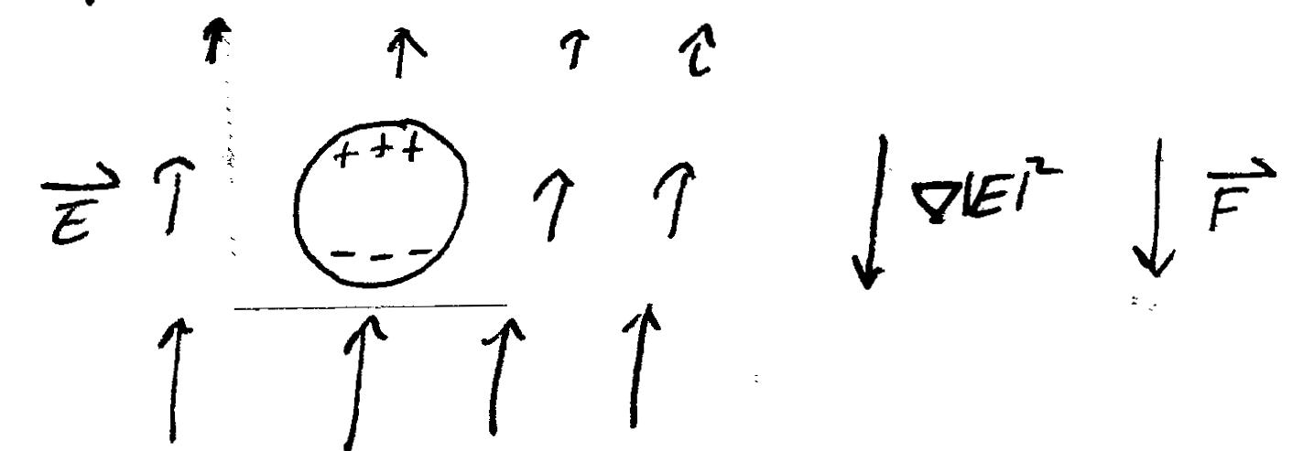
E.g. Gaussian beam at focus
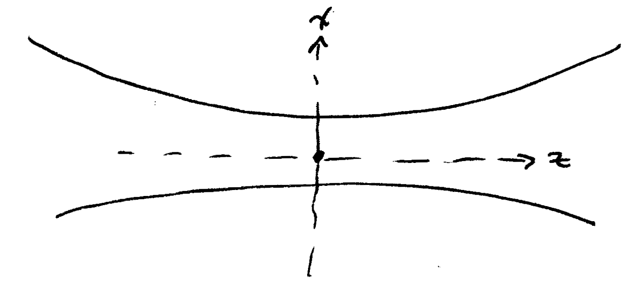

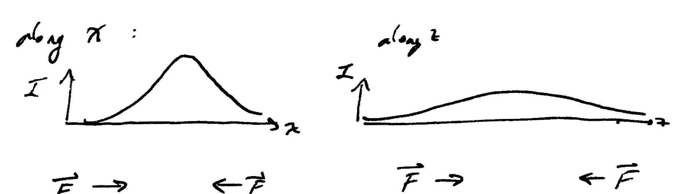

“Optical tweezers”

