Lecture 12
In fact, we shall see shortly that the dipole moment a Lorentz atom is proportional to the applied field, so
Where the proportionality constant is called the polarizability .
Then
But
Or
Which is the force on the center of mass of the atom. It just follows the gradient of the intensity!
Now for any kind of small (sub -) dielectric particle in a weak electric field
e.g. for a dielectric sphere with index n in a medium with,def. ,
So if , and this particle can be trapped
E.g. Gaussian beam at focus
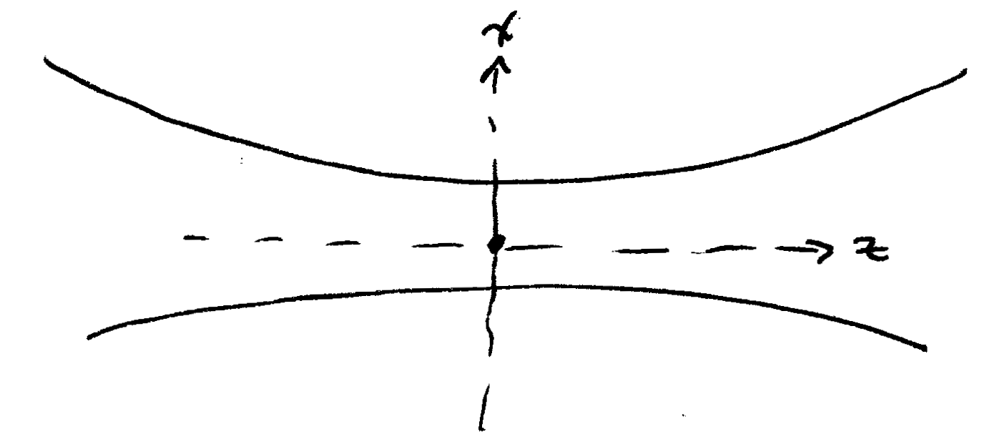

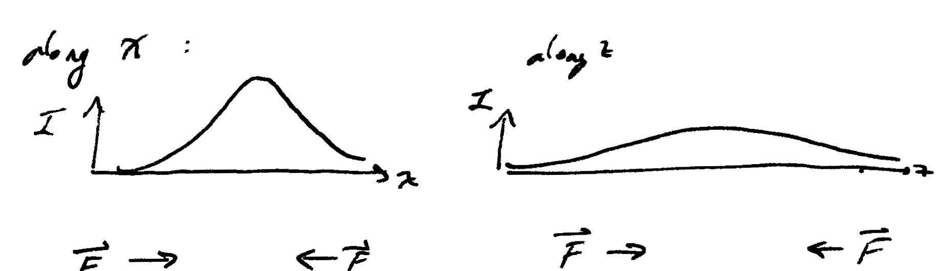
“Optical tweezers”

Back to the internal coordinate:
The second and forth terms in the r.h.s. are negligible in the dipole approximation (i.e. in keeping only the first term in the Taylor expansion, we are assuming they are small)
Numerical justification:
= Bohr radius
Thus the gradient form is 1000 times less than the direct force on the electron. Also, is small, since the force exerted on it is small (and the total mass M is big ).
Thus
Lorentz: assume a harmonic restoring force for small displacements x :
Where is the oscillator’s natural frequency. (note m = reduced mass )
=>
As we have seen, the oscillator must be damped, since the oscillator dipole radiates power
- add a “friction” term (as usual velocity )
- Lorentz eqn. of motion for a single driven atom

Polarization and energy decay
The free-field (homogeneous) solution is that of an oscillating atom with E = 0.
Try a solution of the form
Plug these into the Lorentz eqn. and divide out
The real and imaginary parts must separately=0:
Im: amplitude decay rate
Re:
Or Oscillation frequency (renormalized by damping)
Thus the dipole oscillates at a frequency nearly equal to the nature frequency,but shifted slightly downward due to the damping.

For all cases we might consider (indeed nearly all cases in optics)
Typical numbers:
Thus the frequency shift is negligible, and the solution is :
Note that the dipole moment (or atomic polarization) decays at a rate
The energy decays with a rate:
(since the energy goes as the square of the polarization .
Normally, we identify.In many circumstances, these can also be nonradiative energy relaxation, so

Macroscopic Polarization
Our goal is to understand the propagation of light in a uniform medium. Therefore we must extend the treatment from consideration of the polarization of a single atom to determine the macroscopic polarization induced in an uniform medium containing N dipoles per unit volume .
The simplest approach, taken by most authors, is to write
N = total # dipoles /volume
However, this is not strictly true in the classical model.
Our treatment will follow that of Siegman,chap.2.
The correct way to obtain is
(note: the vector sum )
Why? (1) Not all the dipoles necessarily point in the same direction ; collisions can reorient them.
(2)The dipole may not all have the same phase .
e.g. a snapshot in time
=>
direction + amplitude
phase
Collisions or coupling to vibrations (phonons) in a solid will generally cause to change directions at random times, and to make random jumps at random times.
Note: if phases and directions are random, then
Even though for any specific dipole
Thus in general
See S## fig.2.6 (next page) for N=3 case.
Note: amplitudes of individual oscillators unchanged!
Now suppose that at time t=0,all the dipoles are aligned and in phase (e.g. by a short pulse of light).
Suppose that every time a collision occurs, it randomizes the phase (and /or direction)
Thus, for all the dipoles which have undergone collisions,
In other words, we consider
=constant
Where = # dipoles in phase (have not yet collided)
= # dipoles which have collided
At time t=0, . As time increases, as .The macroscopic polarization is just
Terminology: these collisions are called dephasing collisions, since they randomize the individual dipoles’ phases, thereby reducing the macroscopic polarization.
Note that collisions might (and usually do) cause the dipoles to dephase without actually changing the amplitude (and hence the energy) of any individual dipole. We must discriminate between dephasing collisions and energy-changing collisions.

Note on collisions:
Although the approximation that collisions are “abrupt” (so the phase changes occur instantaneously even on the time scale of the period of lights) is often made for mathematical + conceptual convenience, it is clearly not true.
Typical atomic velocity (thermal) ~ 1 km/s
Typical atomic size ~ 1 Å
Time scale for collision =
Which is period of light (~ 2fs)
Our picture of collision – induced dephasing should be:
R =distance between atom A and atom B
B = “impact parameter“ (minimum R)
e.g.

When random due to randomness in b

Thus instead of abrupt collisions, one has a “slow” collision, and the phase of the atomic dipole is random after the collision is over (w.r.t the phases of other dipoles in the ensemble)

In a dilute gas, the time between collisions will be much larger than the duration of a single collision, so the collisions may be considered to be independent.
In a solid, the atoms cannot move much, but can only vibrate near their equilibrium lattice positions (phonons).
Nevertheless, the randomness of the phonons induces dephasing in much the same way as collisions in atom gas do.
Suppose dephasing collisions occur with a rate
Then the number of collisions occurring in a time interval dt is
=>
=>
Therefore the macroscopic polarization decays at a rate
A common notation in the literature defines
= energy decay rate
= polarization decay rate
Note that, in the absence of “extra dephasing” such as pure dephasing collisions, one would have
In general,

